FPA PROFESSIONAL DEVELOPMENT PLAN TEMPLATE

July 2016

INTRODUCTION

A Professional Development Plan (PDP) sets out the identified learning activities that support the development of technical competencies, professional skills and personal attributes required for effective performance and participation within the financial services industry.

The PDP sits at the centre of the Professional Dimensions Model and it is an FPA requirement that any CPD undertaken in order to meet your professional obligations is captured in this plan.

It is an FPA requirement that each member develops a Professional Development Plan and maintains a record of the Professional Development they undertake.

The plan should be comprehensive and development opportunities considered from each professional dimension.

THE PDP PROCESS

The following template works through a 5 step process which aims to help you identify CPD opportunities across each professional dimension, record your CPD activity and reflect on your learning experiences to identify new opportunities.
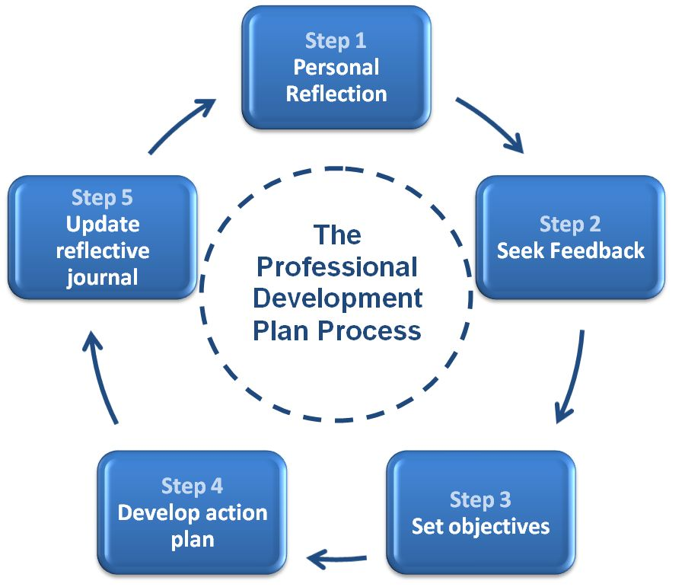

Name: Licensee: Date:

STEP 1: PERSONAL REFLECTION
You can use the example reflection questions to help you to identify CPD Opportunities across each professional dimension. Definitions of each dimension as well as example CPD Activities are provided in Section 2 of the FPA CPD Policy.

CAPABILITY: The technical, legal, product and industry knowledge that it takes to advise your clients and run your business
Reflection Questions  Am I up to date with the impacts of federal budgets, legislation and economic developments that have taken place?  Have I met ASIC’s requirement to maintain, update and develop my knowledge and skills in the areas in which I give advice?  Am I up to date with the most current strategies impacting my clients?  Are there any other areas of financial planning that I would need or like to explore? For example SMSFs, Estate Planning?  Do I need to update my knowledge to improve the performance of my own practice?  Do I need to have a better understanding of succession planning? | Notes
CPD Opportunities

PROFESSIONAL CONDUCT: All the skills and knowledge that go into making good, informed and client centred decisions
Reflection Questions  Am I up to date with FPA’s code of conduct and practice standards?  Am I up to date with my compliance obligations?  Do I need to up-skill in any areas following my last compliance audit?  Is there anything I need to improve upon in the area of complaints?  How do (or did) I deal with ethical dilemmas?  How aware am I of my own personal ethics and values and do I know how they impact my clients (for example do I inspire trust and confidence).  How do I reflect my ethics in my client value proposition?  How do I ensure the advice I give is client centred and ethically based? | Notes
CPD Opportunities

CRITICAL THINKING: The skills of how to process complex information and create new solutions
Reflection Questions  How do I apply my technical capabilities to unique client situations?  Have I developed appropriate strategies to deal with current market and economic conditions?  How do I demonstrate to clients the basis for my adVice?  Do I adequately seek new advice opportunities and solutions for clients?  Do I adequately identify potential conflicts and risks?  Have I kept up-to-date with the current industry issues that may impact the plans already in place for existing clients? | Notes
CPD Opportunities

REFLECTIVE PRACTICE: Skills in developing others and yourself – thinking about the professional and personal needs of others as well as your own
Reflection Questions  Can I improve my approach to my own professional development?  Have I established career objectives for the next year, the next 5 years and beyond?  Do I know what others see as development opportunities for me?  Do I reflect on my experiences to identify learning opportunities?  Do I seek feedback from my colleagues and clients? If so what does it tell me? Do I need to make improvements?  Do I seek feedback from my clients?  Am I open to constructive feedback?  Am I achieving what I set out to do? | Notes
CPD Opportunities

INTERDEPENDENCE: How your engage with the profession, the industry and your peers in ways that instil consumer confidence
Reflection Questions  What opportunities do I have to contribute to the profession?  Can I get involved in community education?  What opportunities do I have to undertake pro-bono work?  Am I in a position to mentor less experienced planners?  Can I run education sessions for other planners or for community groups?  How do I engage with the FPA? | Notes
CPD Opportunities

ATTRIBUTES AND PERFORMANCE: Skills in building professional relationships and improving your own professional performance
Reflection Questions  Do I understand my professional strengths and weaknesses?  What differentiates me from others?  Are there any opportunities to improve my job satisfaction?  Have I developed an effective network and do I know how to use it well?  What feedback do I get from my clients?  Do my clients consider me ‘referable’? How do I know?  How do I manage conflict? Could it be better?  Do I negotiate workable solutions?  Am I managing the pressures of work as well as I can?  Do my communication and presentation skills need improving?  What leadership qualities do I have, and what skills need further refinement?  Do I know if I am an effective leader?  Who inspires me? What is it about them that I would like to learn? | Notes
CPD Opportunities

STEP 2: SEEK FEEDBACK

Review your reflection with your supervisor, mentor, colleagues and staff to gain further insight and develop new opportunities. They may assist you in identifying additional CPD Opportunities across each dimension. List any newly identified Opportunities below:

1. | 2.
3. | 4.
5. | 6.

STEP 3: SET OBJECTIVES

Your objectives describe what you want to achieve. Use the information gathered from your reflection to identify three objectives that you would most like to achieve professionally over the next year.

Objectives  List the professional objectives you want to achieve | Key Performance Measures  What would indicate these had been achieved?
1. | 1.
2. | 2.
3. | 3.

STEP 4: DEVELOP AN ACTION PLAN

Name: Licensee:
Start Date: End Date:

CPD Activity | Professional Dimenson | Due Date | Delivery method | Provider Name

STEP 5: KEEP A REFLECTIVE JOURNAL

The purpose of the reflective journal is to encourage you to observe your own experiences, analyse what happened and think about ways to use these experiences to improve and develop professionally.

The Reflective Journal can be used to assist you in capturing learning from real life situations, or to assist you in applying formal learning into practice.

Reflection Questions | Your Response
What was the situation?
What happened in this situation?
How did you go about it?
Why did you go about it that way?
What was the outcome?
What did you do well?
What could you have done better?
What would you do differently next time?

